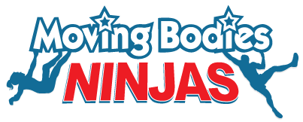**Moving Bodies Ninja Consent**

Moving Bodies agrees to provide a safe Ninja environment for all participants.

The participant acknowledges that the Ninja Course is a recreational service for the purposes of, and as defined in, Section 139A of the Competition and Consumer Act 2010 and that participation in the activities are voluntarily for the use of recreation, enjoyment or leisure, notwithstanding the risks of participation.

The participant acknowledges the possible risks involved with Recreational Activities, including the risk of personal injury and death.

The participant shall hereby release, forever discharge, and agree to indemnify and hold harmless Moving Bodies Pty Ltd from any and all loss, damage, liability, claim, demand, expense (including any legal expenses reasonably incurred in the enforcement of these terms and conditions), which is caused or contributed by negligent or wrongful act or omission in connection with the participation in, or use of the Services.

By providing details below, you acknowledge you have read and agree to the consent above.

|  |  |  |
| --- | --- | --- |
| Participants Name | Participants Age | Permission to participate on the Moving Bodies Ninja Course? |
|  |  |  |
|  |  |  |
|  |  |  |
|  |  |  |
|  |  |  |
|  |  |  |
|  |  |  |
|  |  |  |
|  |  |  |
|  |  |  |
|  |  |  |
|  |  |  |
|  |  |  |
|  |  |  |
|  |  |  |
|  |  |  |
|  |  |  |
|  |  |  |
|  |  |  |
|  |  |  |
|  |  |  |